Experiment 10

# Student Name: Shubham Kr Shrivastav UID: 20BCS4120 Branch: CSE CC1 Section/Group: B

**Semester: 5th Date of Performance: 08-11-22 Subject Name: Computer Network Lab Subject Code: 20CSP-342**

# Aim/Overview of the practical:

Using Socket programming implement the Connectionless service using standard Ports in any programming language (Java/Python etc).

1. **Requirements:** PC, JDK, CMD/Terminal or any JAVA IDE like IntelliJ.

# Theory:

**Java Networking:** Java Networking is a concept of connecting two or more computing devices together so that we can share resources.

Java socket programming provides facility to share data between different computing devices.

# The java.net package supports two protocols

**TCP:** Transmission Control Protocol provides reliable communication between the sender and receiver. TCP is used along with the Internet Protocol referred as TCP/IP.

**UDP:** User Datagram Protocol provides a connection-less protocol service by allowing packet of data to be transferred along two or more nodes.

**Socket:** A socket is an endpoint between two-way communications. Visit next page for Java socket programming.

**java.net package:** The java.net package provides many classes to deal with networking applications in Java.

# Steps for experiment:

* 1. Open any text editor or any JAVA Supported IDE.
  2. Add the code given below and save file as **DSender** and **DReceiver** respectively with

.java extension.

* 1. Run the code on to the IDE or CMD.
  2. Send message from client side and do the same from the server side.
  3. You will be able to see the message and the program will be terminated.

# Code: DSender.java

import java.net.*;

import java.util.Scanner;

public class DSender {

public static void main(String[] args) throws Exception { Scanner sc = new Scanner(System.*in*);

DatagramSocket ds = new DatagramSocket(); String str = sc.nextLine();

InetAddress ip = InetAddress.*getByName*("127.0.0.1");

DatagramPacket dp = new DatagramPacket(str.getBytes(), str.length(), ip, 3333); ds.send(dp);

ds.close();

}

}

**DReceiver.java**

import java.net.DatagramPacket; import java.net.DatagramSocket;

public class DReceiver {

public static void main(String[] args) throws Exception { DatagramSocket ds = new DatagramSocket(3333);

byte[] buf = new byte[1024];

DatagramPacket dp = new DatagramPacket(buf, 1024); ds.receive(dp);

String str = new String(dp.getData(), 0, dp.getLength()); System.*out*.println("Sender says:" + str);

ds.close();

}

}

# Result/Output:

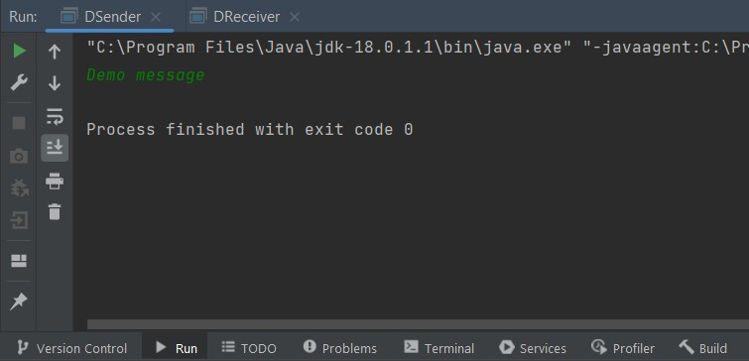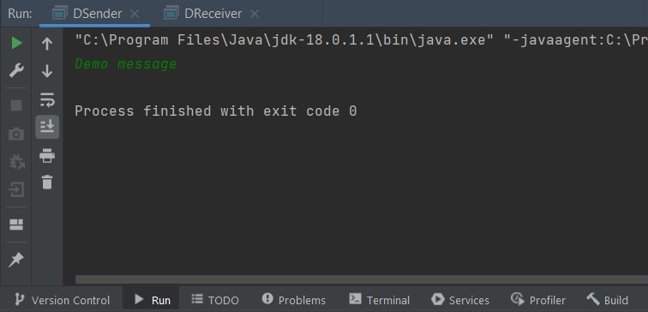

**Learning outcomes (What I have learnt):**

* Leant how to establish connection using java.
* Learnt the creation of connection ports.
* Learned about different networking libraries of JAVA.

**Evaluation Grid (To be created as per the SOP and Assessment guidelines by the faculty):**

|  |  |  |  |
| --- | --- | --- | --- |
| Sr. No. | Parameters | Marks Obtained | Maximum Marks |
| 1. |  |  |  |
| 2. |  |  |  |
| 3. |  |  |  |
|  |  |  |  |